Project Design Phase
Solution Architecture

Date | 28 seltemSeptember 2026
Team ID | SWTID-2026-9713
Project Name | AI FitTrack API
Maximum Marks | 4 Marks

Solution Architecture:
AI FitTrack API is a backend REST API designed to manage fitness-related user data, authentication, workout/fitness tracking services, and AI-based fitness recommendations. The API receives client requests, processes them through the appropriate service modules, stores and retrieves data from the database, and returns structured responses to the client.
- Find the best tech solution to solve existing business problems.
- Describe the structure, characteristics, behavior, and other aspects of the software to project stakeholders.
- Define features, development phases, and solution requirements.
- Provide specifications according to which the solution is defined, managed, and delivered.


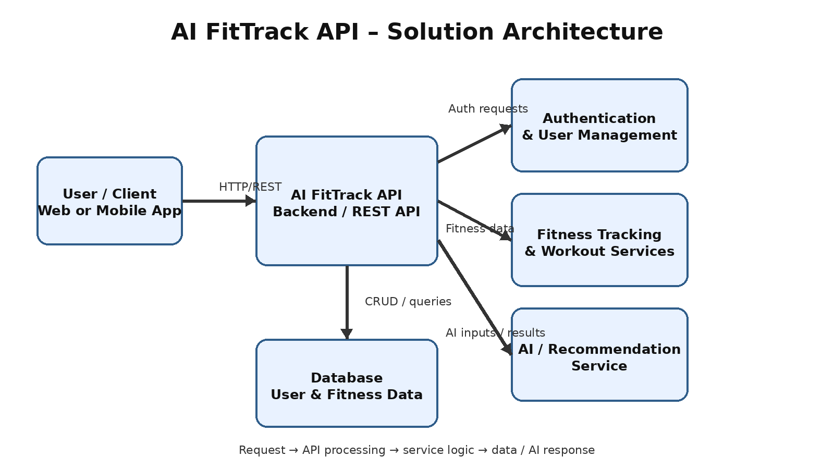
Figure 1: AI FitTrack API solution architecture and data flow

